In 1066 the Normans took over England after victory at the Battle of Hastings. They have since taken over land and all of England is ruled by William and his men. To protect themselves they have built castles all around the country. Every time you step outside of your hut you can see the castle, it is a reminder of who are your rulers.
You have had enough of paying taxes, working on the land and being insulted by Normans. You decide to attack the castle. You will have to answer was it difficult to take over castles in the Medieval times?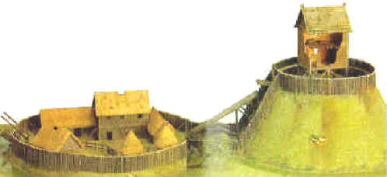
You will plan your attack to destroy the Norman castle and drive them out of England
- You have a budget that you can use to buy weapons
- You cannot go over the budget if you do then you instantly fail
- You will then be using the weapons that you bought to plan your attack
- You will also need to give a reason for buying the goods

Before you write down your attack read the sources to see if they can help decide Items you need to buy and why.
Sources
Source A:
“We must launch missiles at the castle and break it down before we try and enter it. If we go charging in then we can be easily picked off by those defending the castle” written by an army leader in the Medieval times
Source B:
There is a need to be fast and to keep moving that way people in the arrow cannot fire at us. If we are fast then we are harder to hit and they will run out of things to throw
Source C:
They can only stay in the castle for so long before they run out of things. When they need to come out then we will be ready to attack
Source D:
We have a bigger army than the Normans. By the time William gets his army here we can take over and get rid of the Normans for good.
Local peasant
Source E:
With Castles we can control the English. They are too high for their weapons to hit us. They will be crushed before they get a chance.
From a Norman Lord
Source F:
The English have lost the war, they will now pay taxes and our castles cannot be beaten.

You have a budget of £5,000

You can buy the same things more than once!
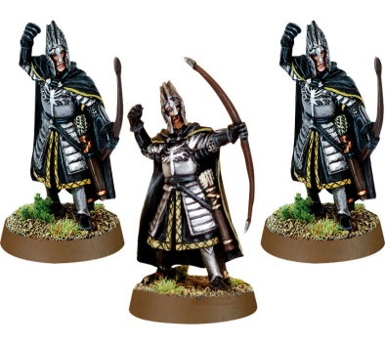
Archers: They fire arrows and can use fire arrows to attack the castle. They can be accurate with their shots but many arrows don’t do any damage.
£200 for 20 archers

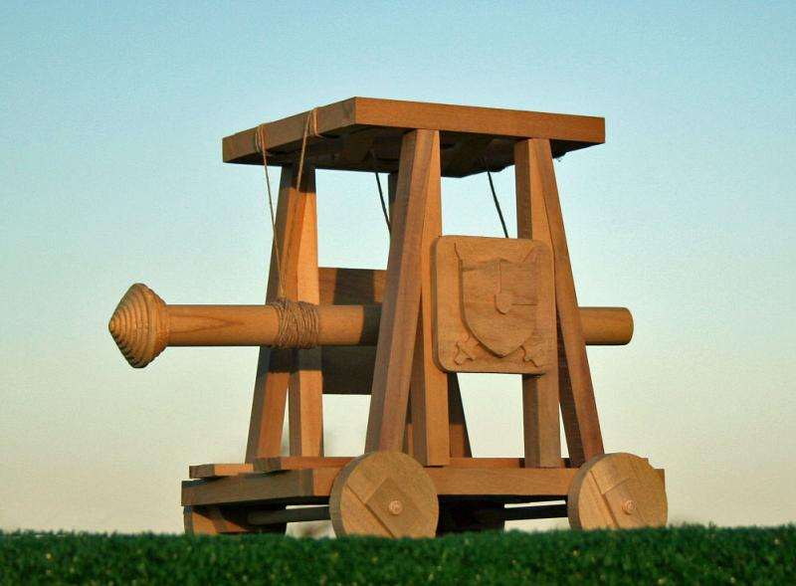
Battering Ram: These are used for breaking down doors and walls. They are strong if you are able to push them and cause a lot of damage. A problem of them is they are difficult to use on hills as they are hard to push up
£150 for 1

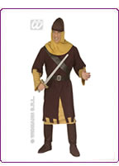
Soldiers: The men on the ground are well trained and brave. They will attempt to storm the castle and attack anyone in their way. One problem they face is they can be attacked by the people defending the castle as they are marching towards it.
£300 for 100 soldiers
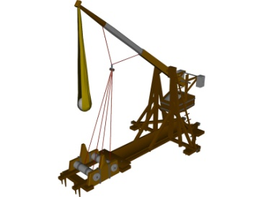 Catapult: These are good weapons to launch objects at the castle. They can be loaded with rocks and go over the fence or wall. If they hit the wall they can cause damage. A problem is they are not very accurate.

£500 for 3

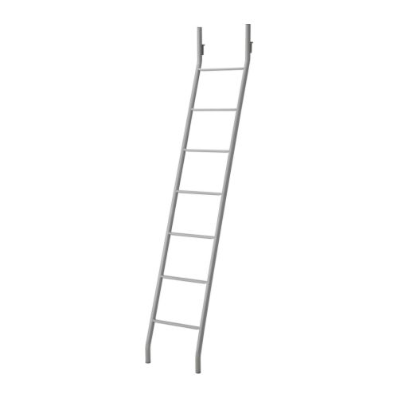
Ladder: They can be used to climb up castle walls. They can get you over into the grounds where you can attack. The negative of them is they can be pushed over when the soldier is climbing.

£50 per ladder


Food: You will need to feed your army as you want them to be strong and able to fight. They will need to eat a lot as the long battle to take the castle begins. The issue of feeding all the soldiers is they might eat all of it and leave none for you after the battle is over

£250 for 2 days
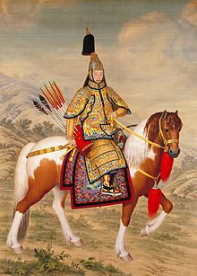
Cavalry: These are soldiers on horseback. They can attack quickly and cut down the opposition. They are unlikely to be able to break through the walls and would on be effective if you got into the castle grounds.

£300 for 20
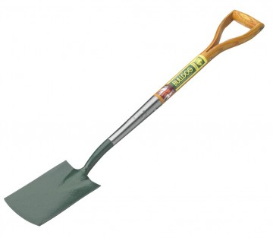
Spades: You could try and dig under the castle to get inside from below. The opposition would not see you and so they would not shoot you. The dangers of this are being caught underground and also the castle could collapse on you crushing you to death

£100 for 10 spades

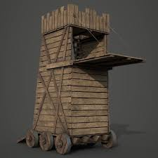
A siege tower or breaching Tower (breaching means to get in.
This is a specialized ladder, constructed to protect attackers and ladders while approaching the defensive walls of a castle. The tower was often rectangular with four wheels with its height roughly equal to that of the wall or sometimes higher to allow archers to stand on top of the tower and shoot arrows into the fortification. However ecause the towers were wooden and thus flammable, they had to have some non-flammable covering of iron or fresh animal skins.
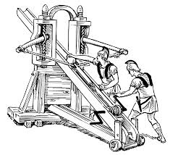
£ 650 per Towers
A Ballista is an ancient military siege engine in the form of a crossbow. Typically it was used to hurl large bolts, and had better accuracy than a catapult at the expense of reduced range.
£325

Using the information from your attack now answer the key question:
Why were castles hard to attack in the Medieval times?
How to structure your piece of writing
Introduction
Why did the English hate the Normans?
How did the castles help the Normans control the English?

Main
Why was your plan good? Give reasons why you think it would be successful

Why did you put the things you bought where you did?

Why might your plan fail? Give reasons

Why were castles hard to take over?

Conclusion
Answer again why was a Norman castle hard to attack?
Why did Castles help the Normans control the English

